**CODTECH INTERNSHIP TASK -1**

**CLOUD STORAGE SETUP:-**

CREATE AND CONFIGURE CLOUD STORAGE ON AWS S3 OR GOOGLE CLOUD STORAGE.

DELIVERABLE: A BUCKET SETUP WITH EXAMPLE FILES UPLOADED AND ACCESS PERMISSIONS CONFIGURED.

1. BUCKET SETUP:-

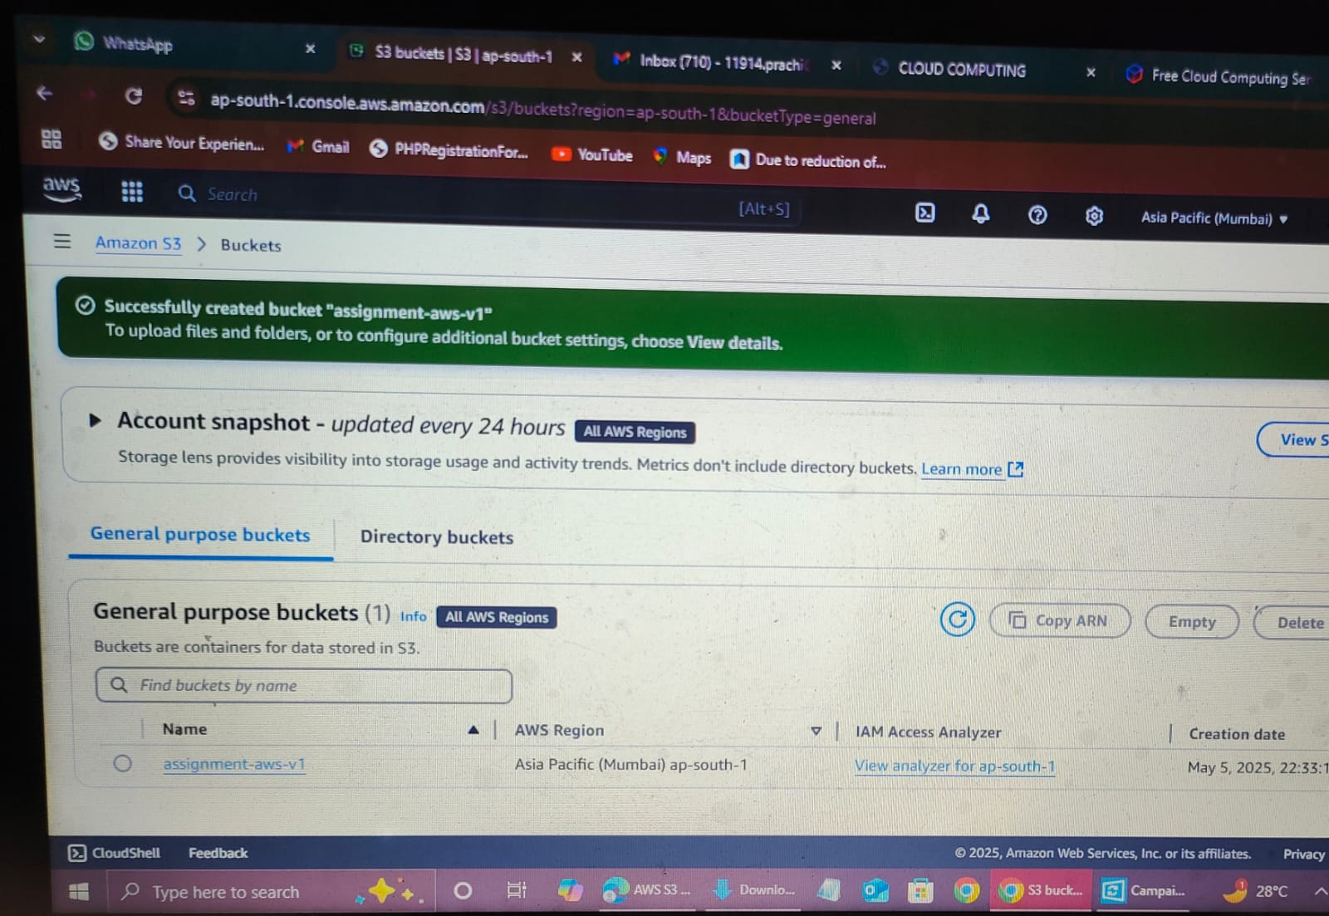

1. FILES UPLOADED:-

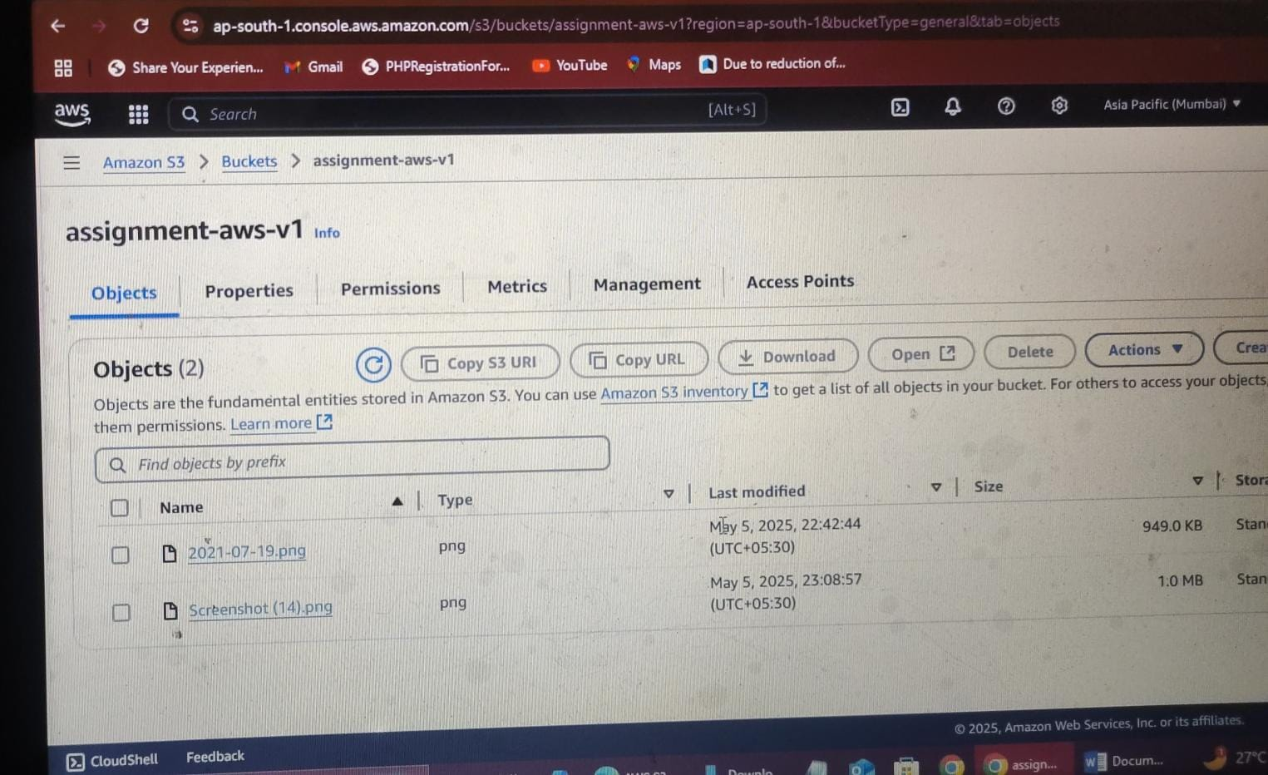

1. ACCESS PERMISSIONS CONFIGURED:-

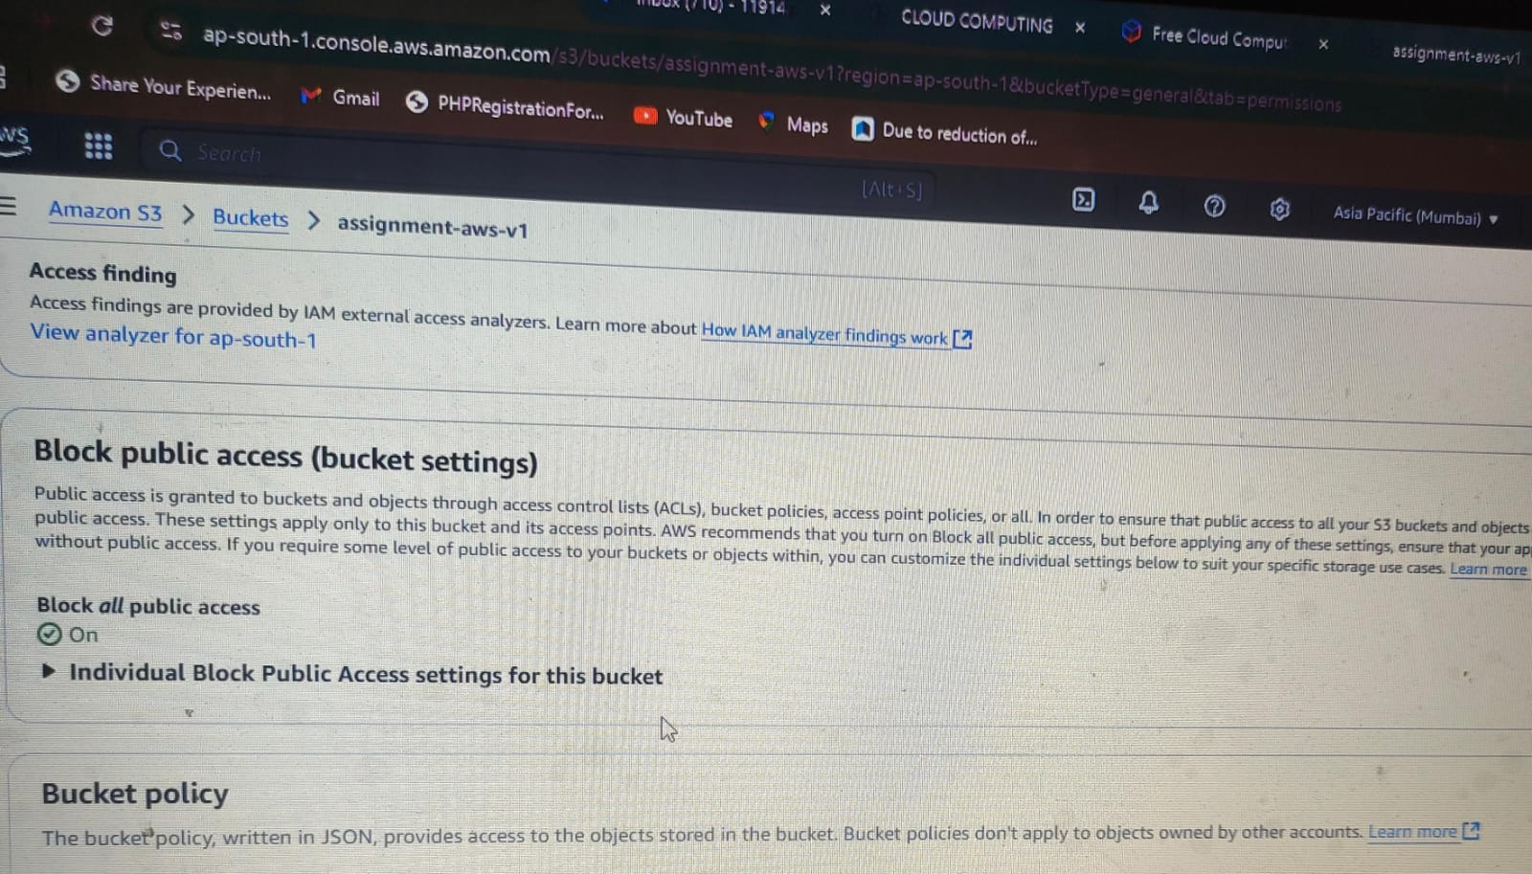

**THANK YOU!**